***Assignment 3***

**Que 1:**

**import java.util.Scanner;**

//The above statement will import scanner class

**public class EmpSalCal {**

**public static void main(String[] args) {**

**int num=0,annSal;**

**double fullTime,hoursWorked,partTime,sessional,partialLoad;**

**final float RATEOFPAYPT=30.00f,RATEOFPAYS=32.00f,RATEOFPAYPL=35.00f;**

//fixed values of rate of pay

**Scanner input=new Scanner(System.in);**

/* The above statement will create new instance variable of

scanner class and it will take inputs from console */

**System.out.println("Enter Type of Employee");**

**System.out.println("1. Full-Time");**

**System.out.println("2. Part-Time");**

**System.out.println("3. Sessional");**

**System.out.println("4. Partial Load");**

**num=input.nextInt();**

//take the input from the user

**if (num==1)**

//if given input is 1 then it will execute below statement

**{**

**System.out.println("Enter Annual Salary: ");**

**annSal=input.nextInt();**

//take input of annual salary from the user

**fullTime=(double) annSal/44;**

//it will count the fulltime salary and will have value in double.

**System.out.println("Entered Salary: $" +annSal);**

**System.out.println("Total Pay: $" +fullTime+"0");**

**}**

**else if (num==2)**

//if the input number is 2 then it will execute the below statements

**{**

**System.out.println("Enter Hours Worked: ");**

**hoursWorked=input.nextDouble();**

//will take the input ,number of hours, from user

**partTime=(double) hoursWorked*RATEOFPAYPT;**

//will count the part time salary and give output in double

**System.out.println("Entered Hours Worked: " + hoursWorked);**

**System.out.println("Total Pay: $" +partTime+"0");**

**}**

**else if (num==3)**

//if the entered number 3 is then execute the below statements

**{**

**System.out.println("Enter Hours Worked: ");**

**hoursWorked=input.nextDouble();**

//will take number of hours as input from user

**sessional=(double) hoursWorked*RATEOFPAYS;**

//will count sessional salary in double

**System.out.println("Entered Hours Worked: " + hoursWorked);**

**System.out.println("Total Pay: $" +sessional+"0");**

**}**

**else if (num==4)**

//if the input of user is 4 then it will execute below statements

**{**

**System.out.println("Enter Hours Worked: ");**

**hoursWorked=input.nextDouble();**

//will take number of hours as input from user

**partialLoad=(double) hoursWorked*RATEOFPAYPL;**

//will count partial load salary in double

**System.out.println("Entered Hours Worked: " + hoursWorked);**

**System.out.println("Total Pay: $" +partialLoad+"0");**

**}**

**else if (num>=5)**

/*if the input from user is 5 or any bigger number than 5,

it will execute below statements */

**{**

**System.out.println("Error! You Entered an Invalid Employee Type.");**

**}**

**}**

**}**

**Output:**

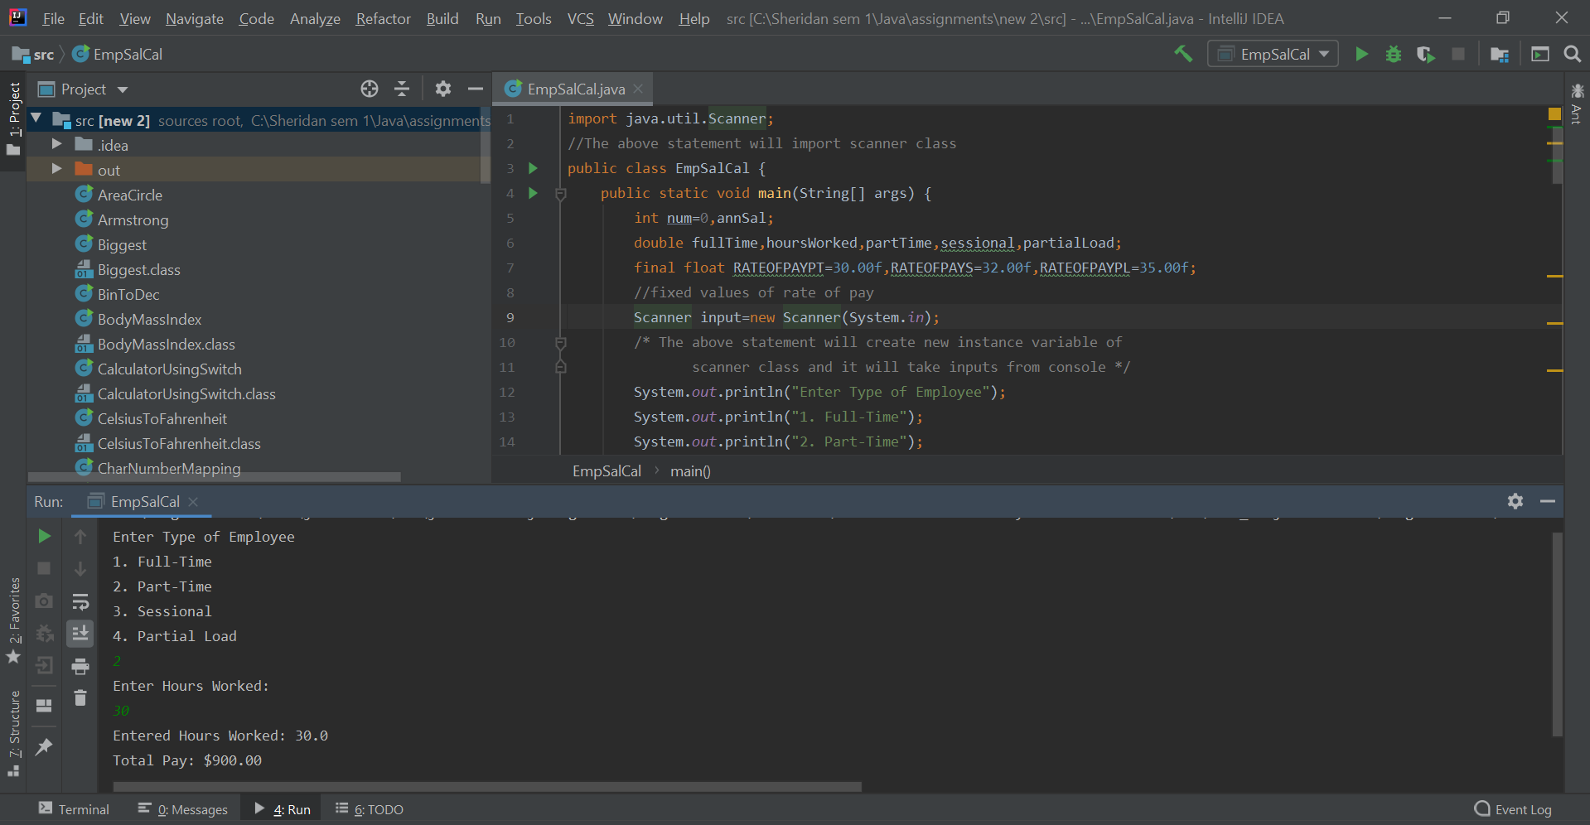

**Que 2:**

**import java.util.Scanner;**

//The above statement will import scanner class

**public class undParkingCharges {**

**public static void main(String[] args) {**

**final float SPECIALRATE=1.00f,REGULARRATE=2.00f,MAXRATE=120.00f,**

**DISRATEFORMOREHOURS=1.50f;**

//fixed values of different parking rates

**double numHoursParked,chragePerHours,totalCharge;**

**int hours=0;**

**String s1="yes",s2="no";**

**Scanner input = new Scanner(System.in);**

/* The above statement will create new instance variable of

scanner class and it will take inputs from console */

**System.out.println("Number of Hours Parked is?");**

**numHoursParked=input.nextFloat();**

//take the input from the user in float

**System.out.println("Do You Have a Special Membership Card? Yes or No?");**

**String ans=input.next();**

//take the input from the user in words

**if((s1.equalsIgnoreCase(ans))&&numHoursParked<=120)**

/*if given input is yes and number of hours parked is less than or

equal to 120 then it will execute below statement

*/

**{**

**System.out.println("Hourly Rate: $" +SPECIALRATE+"0");**

**System.out.println("Number of Hours Charged: " +numHoursParked);**

**totalCharge=(double) (Math.ceil(numHoursParked))*SPECIALRATE;**

/*will multiply number of hours parked with special rate and give

the final answer in double

*/

**System.out.println("Total Charge: $" +totalCharge+"0");**

**}**

**else if ((s1.equalsIgnoreCase(ans)) && numHoursParked>120)**

/*if given input is yes and number of hours parked is greater than

120 then it will execute below statement

*/

**{**

**System.out.println("Hourly Rate: $" +SPECIALRATE+ "0");**

**System.out.println("Number of Hours Charged: " +numHoursParked);**

**System.out.println("Total Charge: $" +MAXRATE+ "0");**

**}**

**else if ((s2.equalsIgnoreCase(ans)) && numHoursParked>=80)**

/* if given input is no and number of hours parked is greater than or

equal to 80 then it will execute below statement

*/

**{**

**System.out.println("Hourly Rate: $" +DISRATEFORMOREHOURS+ "0");**

**System.out.println("Number of Hours Charged: " +numHoursParked);**

**System.out.println("Total Charge: $" +MAXRATE+ "0");**

**}**

**else if((s2.equalsIgnoreCase(ans)) && numHoursParked<=15)**

/*if given input is no and number of hours parked is less than

or equal to 15 then it will execute below statement

*/

**{**

**System.out.println("Hourly Rate: $" +REGULARRATE+"0");**

**System.out.println("Number of Hours Charged: " +numHoursParked);**

**totalCharge=(double) (Math.ceil(numHoursParked))*REGULARRATE;**

/* will multiply number of hours parked with regular rate and give

the final answer in double

*/

**System.out.println("Total Charge: $" +totalCharge+"0");**

**}**

**else if ((s2.equalsIgnoreCase(ans)) && numHoursParked>15)**

/*if given input is no and number of hours parked is greater than

15 then it will execute below statement

*/

**{**

**System.out.println("Hourly Rate: $" +DISRATEFORMOREHOURS+"0");**

**System.out.println("Number of Hours Charged: " +numHoursParked);**

**totalCharge=(double) (Math.ceil(numHoursParked))*DISRATEFORMOREHOURS;**

/* will multiply number of hours parked with discounted rate and give

the final answer in double

*/

**System.out.println("Total Charge: $" +totalCharge+"0");**

**}**

**else**

//if user enter anything then yes or no it will execute below statement

**{**

**System.out.println("Invalid Input");**

**}**

**}**

**}**

**Output:**

